The Rock Cycle

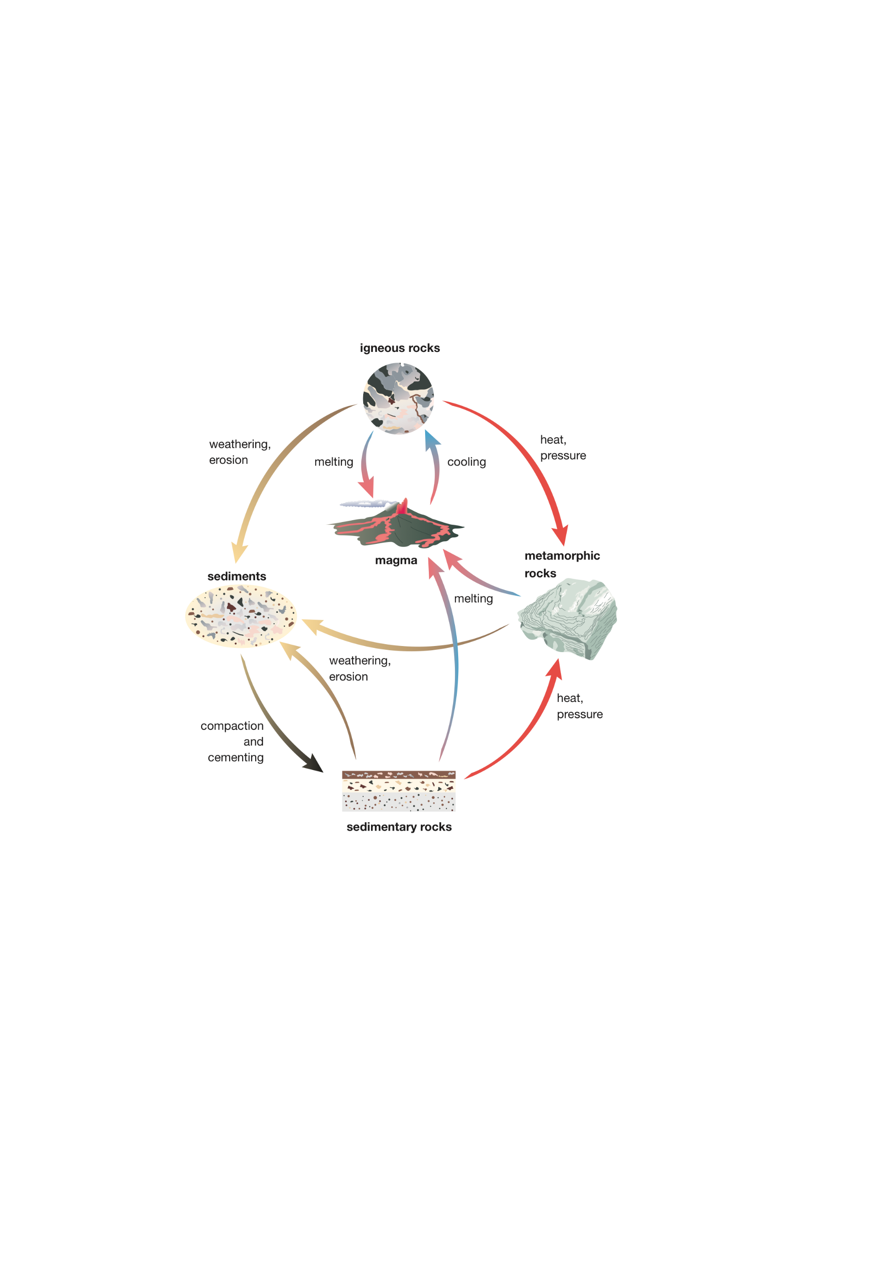

Figure 8.3.1  
A diagram of the rock cycle

Questions

1 Starting at magma in the diagram, **identify** which type of rock forms first, and the process by which it forms.

|  |
| --- |
|  |
|  |

2 Once an igneous rock forms, **explain** how it can be recycled to become an igneous rock again.

|  |
| --- |
|  |
|  |
|  |

3 **Describe** the processes that turn an igneous rock into a sedimentary rock.

|  |
| --- |
|  |
|  |
|  |
|  |

4 **Describe** the processes that turn an igneous rock into a metamorphic rock.

|  |
| --- |
|  |
|  |
|  |
|  |

5 **Describe** the processes that change metamorphic rocks into sedimentary rocks.

|  |
| --- |
|  |
|  |
|  |
|  |

6 **Describe** the processes that change sedimentary rocks into metamorphic rocks.

|  |
| --- |
|  |
|  |
|  |
|  |

7 **Explain** how a sedimentary rock can turn into an igneous rock.

|  |
| --- |
|  |
|  |
|  |
|  |

8 **Explain** how the rock cycle is a useful model in geology.

|  |
| --- |
|  |
|  |
|  |
|  |